The software “worm” operate in combination with output of FLUX allowing to study beam deflection occurring as a consequence of interaction between a crystal and a particle beam. From a physical point of view, beam deflection may occur thought interaction with a bent [1-5] or an unbent [6] crystal.
In the following I will show how to study interaction between a 3 MeV proton beam and a 1.76 µm thick crystal bent at a radius of 50 µm. Figure 1 depicts beam deflection as a function of crystal-to-beam tilt angle. Channeling, volume reflection (VR) , volume capture (VC), and dechanneling regions are clearly seen [3].
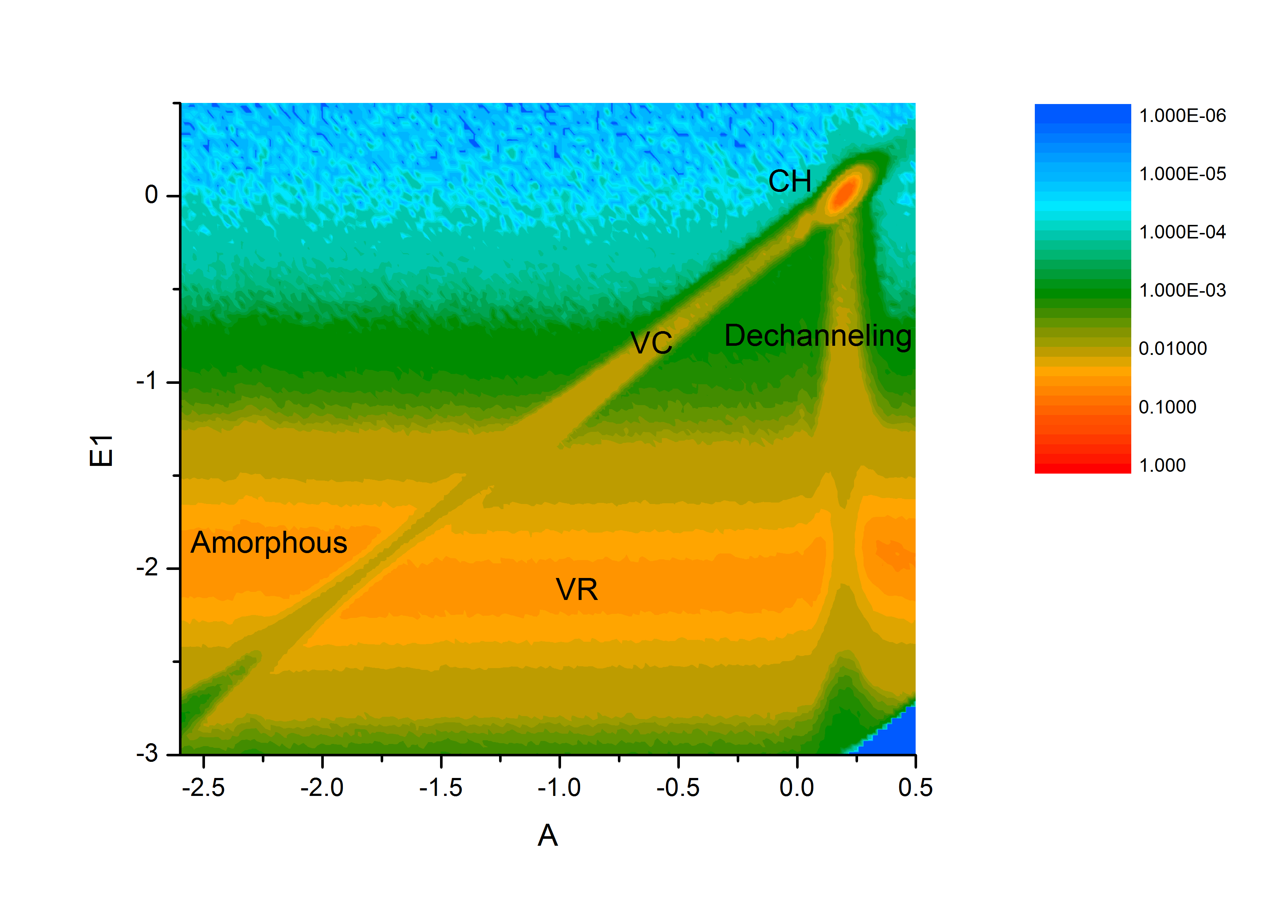
- This is the FLUX input file (please note that energy losses are not optimized for 3 MeV energy but this does not matter too much)

NLAYER
1

LATTICE
GAAS100
1
1 14
1.0 28
505
295
5.431

T0
3 0

DEDX UNWEIGHTED
DEDX VALENCE
0.7 0.7

ELCORE
1582.35552 1191.20648 948.05740 754.39794 590.55153
454.13088 343.68352 256.62912 189.40345 138.41953
100.31031 72.16949 51.60058 36.69527 25.97305
18.30844 12.85907 9.00296 6.28538 4.37704
3.04128 2.10886 1.45964 1.00861 0.69589
0.47947 0.32994 0.22678 0.15571 0.10680
0.07319 0.05012 0.03429 0.02344 0.01601
0.01093 0.00746 0.00509 0.00347 0.00236
0.00161 0.00109 0.00074 0.00051 0.00034
0.00023 0.00016 0.00011 0.00007 0.00005

ZDIST UNIFORM
17600

BEAM DIVERGENCE
0 0 0

NTRACKS
100000

EXITCOORD

CURVATURE
90
500000

ANGLES_P
156
10 0 0.3
10 0 0.28
10 0 0.26
10 0 0.24
10 0 0.22
10 0 0.2
10 0 0.18
10 0 0.16
10 0 0.14
10 0 0.12
10 0 0.1
10 0 0.08
10 0 0.06
10 0 0.04
10 0 0.02
10 0 0
10 0 -0.02
10 0 -0.04
10 0 -0.06
10 0 -0.08
10 0 -0.1
10 0 -0.12
10 0 -0.14
10 0 -0.16
10 0 -0.18
10 0 -0.2
10 0 -0.22
10 0 -0.24
10 0 -0.26
10 0 -0.28
10 0 -0.3
10 0 -0.32
10 0 -0.34
10 0 -0.36
10 0 -0.38
10 0 -0.4
10 0 -0.42
10 0 -0.44
10 0 -0.46
10 0 -0.48
10 0 -0.5
10 0 -0.52
10 0 -0.54
10 0 -0.56
10 0 -0.58
10 0 -0.6
10 0 -0.62
10 0 -0.64
10 0 -0.66
10 0 -0.68
10 0 -0.7
10 0 -0.72
10 0 -0.74
10 0 -0.76
10 0 -0.78
10 0 -0.8
10 0 -0.82
10 0 -0.84
10 0 -0.86
10 0 -0.88
10 0 -0.9
10 0 -0.92
10 0 -0.94
10 0 -0.96
10 0 -0.98
10 0 -1
10 0 -1.02
10 0 -1.04
10 0 -1.06
10 0 -1.08
10 0 -1.1
10 0 -1.12
10 0 -1.14
10 0 -1.16
10 0 -1.18
10 0 -1.2
10 0 -1.22
10 0 -1.24
10 0 -1.26
10 0 -1.28
10 0 -1.3
10 0 -1.32
10 0 -1.34
10 0 -1.36
10 0 -1.38
10 0 -1.4
10 0 -1.42
10 0 -1.44
10 0 -1.46
10 0 -1.48
10 0 -1.5
10 0 -1.52
10 0 -1.54
10 0 -1.56
10 0 -1.58
10 0 -1.6
10 0 -1.62
10 0 -1.64
10 0 -1.66
10 0 -1.68
10 0 -1.7
10 0 -1.72
10 0 -1.74
10 0 -1.76
10 0 -1.78
10 0 -1.8
10 0 -1.82
10 0 -1.84
10 0 -1.86
10 0 -1.88
10 0 -1.9
10 0 -1.92
10 0 -1.94
10 0 -1.96
10 0 -1.98
10 0 -2
10 0 -2.02
10 0 -2.04
10 0 -2.06
10 0 -2.08
10 0 -2.1
10 0 -2.12
10 0 -2.14
10 0 -2.16
10 0 -2.18
10 0 -2.2
10 0 -2.22
10 0 -2.24
10 0 -2.26
10 0 -2.28
10 0 -2.3
10 0 -2.32
10 0 -2.34
10 0 -2.36
10 0 -2.38
10 0 -2.4
10 0 -2.42
10 0 -2.44
10 0 -2.46
10 0 -2.48
10 0 -2.5
10 0 -2.52
10 0 -2.54
10 0 -2.56
10 0 -2.58
10 0 -2.6
10 0 -2.62
10 0 -2.64
10 0 -2.66
10 0 -2.68
10 0 -2.7
10 0 -2.72
10 0 -2.74
10 0 -2.76
10 0 -2.78
10 0 -2.8

EOI

The keypoints in the input file are enabling the option “EXITCOORD” and input a series of angles which defines the angle between the crystal axis and the incoming beam. In this way we can study interaction between the incoming beam and the bent crystal as function of the angle among them. In this example planar alignment changes from 0.3° to -2.8° with steps of 0.02°.

- As usual, output of the simulation will be stored in a logfile. Having enabled the keyword “EXICOORD” the utility “coordfilter”, provided with flux package, will allow you to extract from the log file the “p_{x}” and “p_{y}” components at the exit point from the crystal. This will give you a file containing, for each particle and for each step, momentum components “p_{x}” and “p_{y}” which we can consider to be particle exit angles.

- Now we use the utility worm to extract informations from the file generated by coordfilter. Let’s open the source file and let’s set the following variables

const char flux_file[64] = "bruco_scatterer.coord"; //name of input file, i.e. the file obtained by coordfilter
const char final_file[64] = "bruco_vr.txt"; //name of output file
float step=0.01; //goniometer angular step//
float freqsize=230; //number of bins to be used while computing angular distributions
float maxval=1/57.32; //max value along y axis
float minval=-1/57.32; //min value along y axis
float start=-1; //starting goniometer position

worm will calculate particles angular distribution at every step of the goniometer and will output the result in the text file “worm_vr.txt”

- After compiling and running worm we obtain a text file which we can import into OriginLab or any other scientific software. In the following I will show instructions for OriginLab. From the menu “File” choose “import””single ascii” and select the text file generated by worm. You will have a window like this

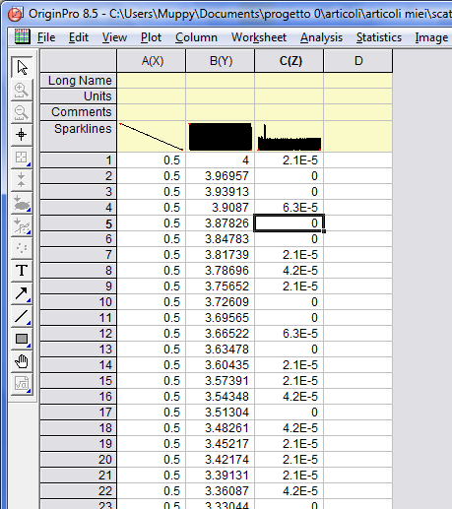

Set the first column on the left as “X” column, the central one as “Y” and the right one as “Z”, so select all the three columns and make a contour plot (“plot””contour””color fill”) to obtain the figure 1 then change the color scare choosing your preferred colors.

References

[1] A. M. Taratin, and S. A. Vorobiev, Physics Letters A 119, 425 (1987).
[2] A. F. Elishev et al., Phys. Lett. B 88, 387 (1979).
[3] W. Scandale et al., Phys. Rev. Lett. 98, 154801 (2007).
[4] W. Scandale et al., Phys. Rev. Lett. 101, 164801 (2008).
[5] W. Scandale et al., Phys. Lett. B 680, 129 (2009).
[6] E. Tsyganov, and A. Taratin, Nucl. Instrum. Methods Phys. Res., Sect. A 363, 511 (1995).

