How to plot trajectories using FLUX (part 1)

FLUX package allows you to draw trajectories of particles interacting with a crystal, see for example Fig 1.
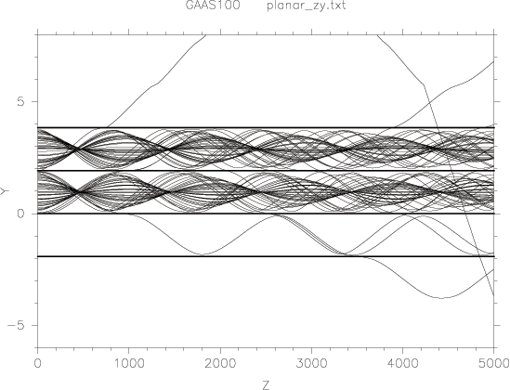
Figure 1. Trajectories of 2MeV protons channeled between (110) planes of a silicon crystal. 100 trajectories are shown
- Prepare your input file putting inside those keyword
NTRACK
100
XYOUT
1
NTRACK is the number of tracks, 100 tracks is good for a nice representation of trajectories.
XYOUT will save in the log file the (x,y) coordinate every “1” step, if you use the keyword
If you use
XYOUT
10
FLUX will save (x,y) coordinate every 10 steps. I typically save coordinates every 1 step.
- Prepare a file with the following code (remove comments in red)
FLUX_PATH/BIN/fluxgo -p FLUX_PATH/BIN/fluxhf planar_zy #this calls fluxgo program, “planar_zy” is the name of you input file
#plot to file
FLUX_PATH/BIN/ztrack <<EOI #this calls ztrack program, the following are arguments are passed to ztrack.
file #this allows ztrack to output trajectories to a file
planar_zy.ps #this is the name of the output file
planar_zy.txt #this is the name of the “flux text file” generated by fluxhf, which is called by fluxgo
yes #this allows to change default scale used by ztrack
-6 +8 5000 #vertical scale will range from -6 to 8 A. Horizontal scale up to a depth of and to a depth of 5000A
EOI #end of input

- Save this file as a script in your “INPUT” directory, for example “planar_zy.sh”, now simply launch this script. You will find in your input directory a file named “plot_zy.ps” like the one showed at the begin of the guide.

